|  |  |
| --- | --- |
| GEN AI LEARNING  **Complete Generative AI Learning – New Year Challenge** | WRITTEN BY: ALOY |

***Day – 22***

Solving Poppler Issue in Windows

<https://www.youtube.com/watch?si=CXcTQdCyca9AxLkd&v=IDu46GjahDs&feature=youtu.be>

**Step1: Download Popller** : [Releases · oschwartz10612/poppler-windows](https://github.com/oschwartz10612/poppler-windows/releases/) ([Releases · oschwartz10612/poppler-windows](https://github.com/oschwartz10612/poppler-windows/releases/))

**Step2:** Extract the downloaded binaries in C:\Program Files (x86) path.

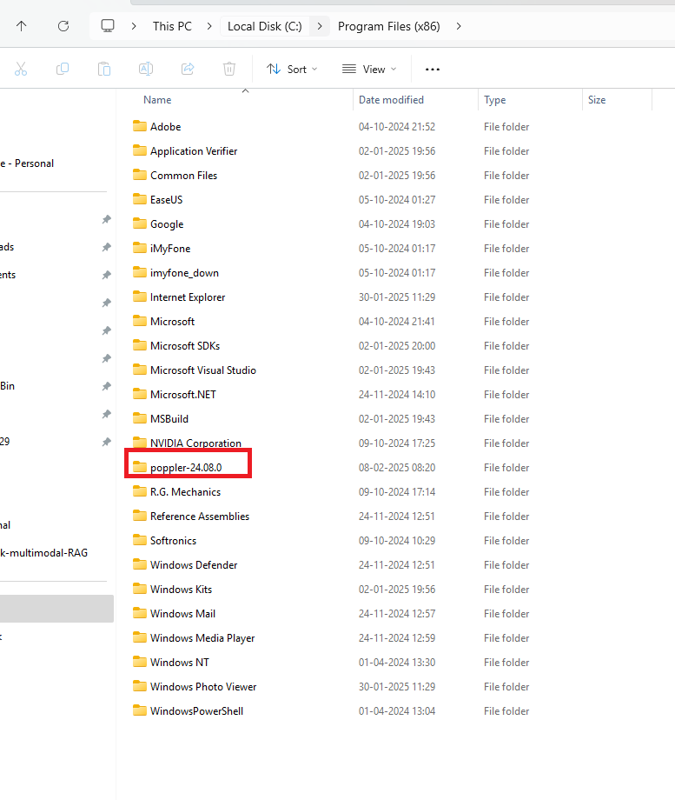

**Step3:** Run below command to check things are working or not

